SIMULATION OF HOT POTATO GAME USING CIRCULAR LINKED LIST

TEAM MEMBERS
DURGA SRI ANJANI-25A31A0573
MALLIDI KAVYA-25A31A0583
GUTTULA VENKATA NAVADEEP-25A31A05AH
MIRTHIPATI SUBHASH-25A31A05AQ

GUIDED BY
MrS.T.N.V.DURGA
Assistant Professor
CSE Department Pragati Engineering College(A)
Surampalem

INTRODUCTION
The Hot Potato Game Simulation using Circular Linked List is a data structure-based project that demonstrates how theoretical concepts can be applied to real-world problems. The Hot Potato game is a popular children’s game where players sit in a circle and pass an object (called the “hot potato”) among themselves. After a fixed number of passes, the player holding the object is eliminated. This process continues until only one player remains, who is declared the winner.
In computer science, such problems can be efficiently solved using appropriate data structures. In this project, a Circular Linked List is used to represent the arrangement of players in a circular manner. Unlike linear data structures, a circular linked list allows continuous traversal without reaching a NULL end, which perfectly matches the circular nature of the game.
This project helps in understanding important concepts such as dynamic memory allocation, pointer manipulation, node traversal, and deletion operations. It also provides a practical implementation of how data structures can be used to simulate real-time systems and solve iterative elimination problems.
The main objective of this project is to simulate the game logically and efficiently, ensuring that players are eliminated in a sequence based on a given number (k), and finally identifying the last remaining player as the winner. This type of problem is also related to the famous Josephus Problem in mathematics and computer science.
Overall, this project not only strengthens the understanding of linked lists but also improves logical thinking and problem-solving skills.

THEORY
1. Linked List
A Linked List is a linear data structure in which elements, called nodes, are stored in non-contiguous memory locations. Each node contains:
- Data (value of the element)
- A pointer/reference to the next node
Unlike arrays, linked lists are dynamic in size and allow efficient insertion and deletion operations.
2. Circular Linked List
A Circular Linked List is a special type of linked list where:
- The last node points back to the first node
- There is no NULL pointer at the end
- The structure forms a closed loop
Characteristics:
- Continuous traversal is possible
- No beginning or end node
- Efficient for cyclic processes
Why it is used in this project:
- The game follows a circular pattern
- Players are repeatedly accessed in a loop
- Eliminations happen continuously without restarting
3. Basic Operations Used
➤ Insertion
Adding players (nodes) into the circular linked list
Usually done at the end to maintain order
➤ Traversal
Moving from one node to another
Used to pass the “hot potato”
➤ Deletion
Removing a node when a player is eliminated
Requires updating pointers to maintain the circular structure
4. Working Principle of the Game
- Players are inserted into a circular linked list
- A pointer is used to track the current player
- The pointer moves k-1 steps forward
- The k-th player is eliminated
- The list is updated after deletion
- The process repeats until only one node remains
5. Relation to Josephus Problem
This problem is closely related to the Josephus Problem, a famous theoretical problem in mathematics. It involves a group of people standing in a circle and eliminating every k-th person until one survives.
This project provides a practical programming approach to solving this classical problem using linked lists.
6. Advantages of Using Circular Linked List
- Efficient representation of circular processes
- No need to restart traversal
- Saves memory by avoiding NULL pointers
- Simplifies repeated operations
7. Applications
- Game simulations (like Hot Potato)
- CPU scheduling (round-robin scheduling)
- Multiplayer turn-based systems
- Music playlist looping
- Real-time systems with cyclic operations
8. Time Complexity
- Traversal for each elimination: O(k)
- Total process: O(n × k)

ALGORITHM: Simulation of Hot Potato Game using Circular Linked List
🔹 Step-by-Step Algorithm
STEP 1:Start
STEP 2: Input
Enter number of players n
Enter the value of k (step count for elimination)
STEP 3: Create Circular Linked List
Create nodes for all players
Link each node to the next
Link the last node back to the first node to form a circle
STEP 4:Initialize Pointer
Set a pointer current to the first player
Set another pointer previous to track the node before current
STEP 5: Repeat until only one node remains
Move current pointer k-1 times forward
Update previous pointer along with current
STEP 6: Eliminate k-th Player
Remove the node pointed by current
Update link:
previous → next = current → next
Move current to the next player
STEP 7:Display Eliminated Player
Print the name/value of the removed node
STEP 8: Continue Process
Repeat steps 5–7 until only one node is left
STEP 9: Declare Winner
The last remaining node is the winner
Display the winner
STEP 10: Stop

- CODE FOR SIMULATION OF HOT POTATO GAME USING CIRCULAR LINKED LIST

#include <iostream>
#include <unistd.h> // for sleep()
using namespace std;
struct Node {
string name;
Node* next;
};
// Create circular linked list
Node* createCircle(int n) {
Node *head = NULL, *temp = NULL;
for (int i = 0; i < n; i++) {
Node* newNode = new Node();
cout << "Enter player " << i + 1 << ": ";
cin >> newNode->name;
if (!head) {
head = newNode;
newNode->next = head;
temp = head;
} else {
temp->next = newNode;
newNode->next = head;
temp = newNode;
}
}
return head;
}
// Animated Hot Potato
void hotPotato(Node* head, int k) {
Node* curr = head;
cout << "\n🎮 Game Started...\n";
sleep(1);
while (curr->next != curr) {
cout << "\n🔥 Passing the potato...\n";
Node* prev = NULL;
for (int i = 1; i <= k; i++) {
cout << "👉 " << curr->name << endl;
sleep(1); // delay for animation
prev = curr;
curr = curr->next;
}
cout << "💥 " << prev->name << " is ELIMINATED!\n";
sleep(1);
// remove prev node
Node* temp = curr;
while (temp->next != prev) {
temp = temp->next;
}
temp->next = prev->next;
delete prev;
}
cout << "\n🏆 WINNER: " << curr->name << " 🎉\n";
}
// Main
int main() {
int n, k;
cout << "🎯 HOT POTATO GAME (Circular Linked List) 🎯\n";
cout << "Enter number of players: ";
cin >> n;
Node* head = createCircle(n);
cout << "\nEnter step count (k): ";
cin >> k;
hotPotato(head, k);
return 0;
}

OUTPUT:

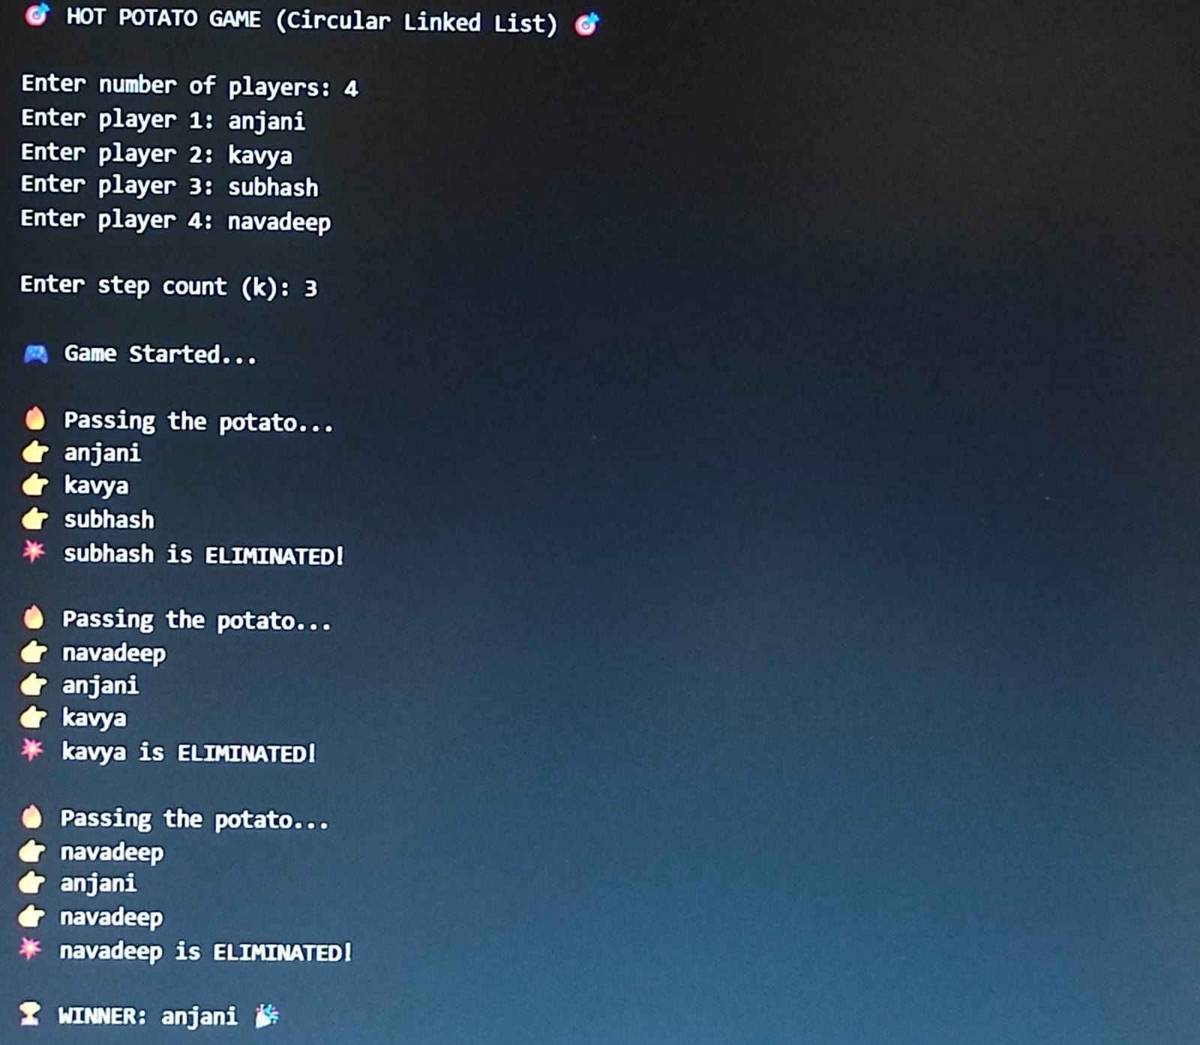

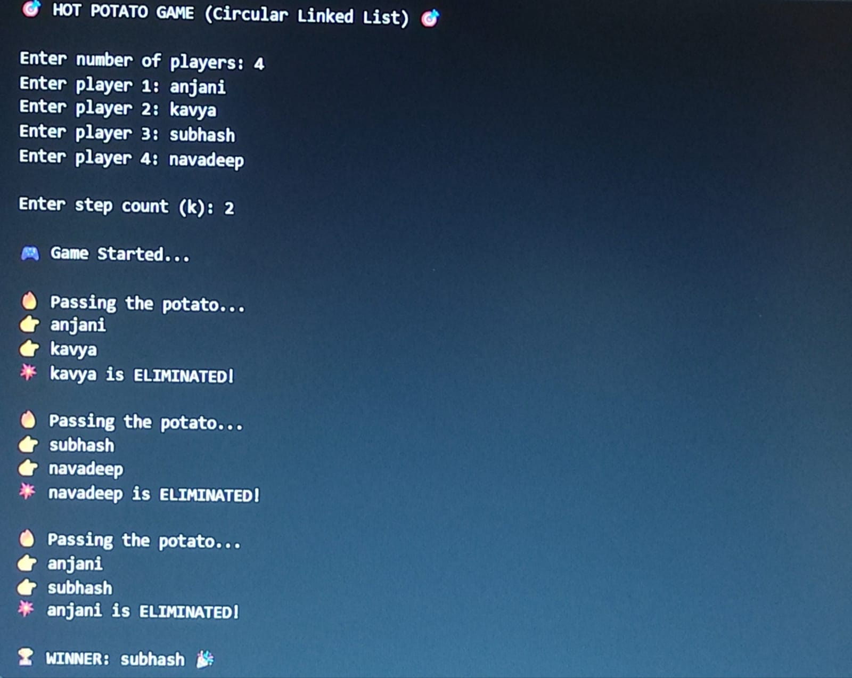

CONCLUSION:
The Hot Potato Game Simulation using Circular Linked List successfully demonstrates how a real-life problem can be solved using data structures. By implementing a circular linked list, the project effectively models the circular nature of the game, where players are continuously traversed and eliminated in a loop.
Through this project, we gained a clear understanding of important concepts such as node creation, traversal, and deletion in a circular linked list. It also helped in improving our knowledge of pointer handling and dynamic memory management. The step-by-step elimination process clearly shows how data structures can be used to handle repetitive and cyclic operations efficiently.
Additionally, this project highlights the practical application of the Josephus Problem, making theoretical concepts easier to understand through programming. It also improves logical thinking and problem-solving skills by requiring careful tracking of nodes during deletion.
Overall, the project proves that circular linked lists are highly suitable for problems involving continuous loops and repeated processes. It serves as a valuable example of applying data structures to real-world scenarios and strengthens the foundation for learning more advanced concepts in computer science.

